

**TINF21C, SWE I Praxisprojekt 2022**

Software Requirements Specification (SRS)

**Project: AAS-Management**

**Customer:** Rentschler & Holder  
 Rotebühlplatz 41  
 70178 Stuttgart

**Supplier:** Team 2 (Paul Brenner, Jonas Alexander Graubner, Mohaddeseh Tibashi, Selvana Dwi Ayunda, Luka Dominik Pavic)  
Rotebühlplatz 41  
70178 Stuttgart

**Version 0.1**

Version History

|  |  |  |  |
| --- | --- | --- | --- |
| Version | Date | Author | Comment |
| 0.1 | 17.10.2022 | Paul Brenner | Created |
| 0.2 | 24.10.2022 | Paul Brenner | GUI Previews |
| 0.3 | 30.10.2022 | Paul Brenner | Implemented Feedback Issue#13 (13#issuecomment-1294110210_) |

Table of contents

Version History 2

Table of contents 2

1 Concept and general conditions 3

1.1 Goal 3

1.2 Product Environment 3

1.3 Product Usage 3

1.3.1 Business Process 3

1.3.2 Use Cases 5

1.4 Features 7

1.4.1 /AASM-F10/ GUI Components 7

1.4.2 /AASM-F20/ Identity Management 7

1.4.3 /AASM-F30/ Access Management 7

1.4.4 /AASM-F40/ Error Display 7

1.4.5 /AASM-FX0/ 8

1.5 Product Data 8

1.6 Other Product Characteristics 8

1.6.1 /AASM-NF10/ Usability 8

1.7 Targetgroup 8

2 Release / Approval 9

3 References 10

# Concept and general conditions

This section illustrates the goal and product environment and presents the characteristics of the web application.

## Goal

The goal of this project is to develop a web application that acts as a management system for the "Asset Administration Shell" (AAS). This specific web application shall have an identity and access management as well as a user administration with persistent data storage in MongoDB. The user administration enables a role distribution of the users in the user groups "Admin", "Advanced" and "Basic", whereby the role distribution is carried out manually via the Admin. Each role is equipped with different access rights and read permissions ("Advanced" gets full read access to all AAS and their submodels and "Basic" gets read access only to the basic submodels to all AAS), with the admin also having functions for managing AAS content and user management. This uses the specification of the concept as a REST API in openapi.

## Product Environment

The AAS is a concept of the Industrie 4.0 platform for the standardized implementation of "Industrie 4.0 components", consisting of the digital twin in the form of the AAS and the associated physical object (the asset). This makes it possible in industry to provide digital twins that can be shared and combined across manufacturers and accessed via standardized interfaces.

## Product Usage

This section reflects on different business processes and use cases which shall be covered by the web application.

### Business Process

|  |  |  |  |
| --- | --- | --- | --- |
| **Nr. / ID** | <AASM-BP.01> | **Title** | Log-In |
| **Triggering Event** | The user opens the GUI and wants to log in his account. | | |
| **Result** | The user is logged in to their account and the GUI has been customized based on the user's user group. | | |
| **Involved Roles** | Any user, GUI and database interface | | |
| **Implementation** | * Login button in top right corner * Opens Login window (username and password) * Login checks for user role * User interface according to user role (Admin: User-Management) | | |

|  |  |  |  |
| --- | --- | --- | --- |
| **Nr. / ID** | <AASM-BP.02> | **Title** | Log-Out |
| **Triggering Event** | The user opens the GUI and wants to log out of his account. | | |
| **Result** | The user is logged out of their account and the GUI has been customized. | | |
| **Involved Roles** | Any user and GUI | | |
| **Implementation** | … | | |

|  |  |  |  |
| --- | --- | --- | --- |
| **Nr. / ID** | <AASM-BP.03> | **Title** | Managing own Account |
| **Triggering Event** | The user wants to change his password and/or e-mail address. | | |
| **Result** | The user changed the password and/or e-mail address. | | |
| **Involved Roles** | Any user, GUI and database interface | | |
| **Implementation** | * User is able to choose Settings in top right corner | | |

|  |  |  |  |
| --- | --- | --- | --- |
| **Nr. / ID** | <AASM-BP.04> | **Title** | Administration |
| **Triggering Event** | The user – an admin – opens the GUI to administrate the AAS. | | |
| **Result** | The user can delete and add AAS content and accounts. Moreover, classify accounts in user groups. | | |
| **Involved Roles** | Admin, GUI and database interface | | |
| **Implementation** | * Logged-In user is provided with a settings option in top right corner (not for Basic Users) * Additional to above options <AASM-BP.03> user with the role “Admin” has the option “Manage users” * This option provides the creation and deletion of users, and changing the email and password for existing users * Furthermore, it provides a selection of the user role for each user (Dropdown-Menu) | | |

|  |  |  |  |
| --- | --- | --- | --- |
| **Nr. / ID** | <AASM-BP.05> | **Title** | Search for an asset |
| **Triggering Event** | The user opens the GUI to find an existing Asset. | | |
| **Result** | The user finds the Asset on GUI. | | |
| **Involved Roles** | The user and GUI | | |
| **Implementation** | * Search option for products is available above the list of products | | |

### Use Cases

|  |  |  |  |
| --- | --- | --- | --- |
| **Nr. / ID** | <AASM-UC.01> | **Title** | Log-In |
| **Related Business Process** | <AASM-BP.01> | | |
| **Use Cases Objective** | User wants to log into account. | | |
| **System Boundary** |  | | |
| **Precondition** | The user's combination of e-mail address and password are valid and stored in the database, and the database system is in operation. | | |
| **Postcondition on success** | The web application shall not be closed until the user is logged in to his account and the user interface is customized according to the user group. | | |
| **Involved Roles** | Any user, GUI and database interface | | |
| **Triggering Event** | User opens the GUI and wants to log into user’s account. | | |

|  |  |  |  |
| --- | --- | --- | --- |
| **Nr. / ID** | <AASM-UC.02> | **Title** | Log-Out |
| **Related Business Process** | <AASM-BP.02> | | |
| **Use Cases Objective** | User wants to log out of his account. | | |
| **System Boundary** |  | | |
| **Precondition** | User is already logged in. | | |
| **Postcondition on success** | The web application shall not be closed until the user is logged out. | | |
| **Involved Roles** | Any user and GUI | | |
| **Triggering Event** | User wants to log out of account. | | |

|  |  |  |  |
| --- | --- | --- | --- |
| **Nr. / ID** | <AASM-UC.03> | **Title** | Managing own Account |
| **Related Business Process** | <AASM-BP.03> | | |
| **Use Cases Objective** | The user wants to use the self-services for e-mail and password change to modify these components of the account. | | |
| **System Boundary** |  | | |
| **Precondition** | The user is already logged in, has the current password of the account and the database system is running. | | |
| **Postcondition on success** | The web application may not be closed until these changes have also been changed in the database system. | | |
| **Involved Roles** | Any user, GUI and database interface | | |
| **Triggering Event** | User wants to change password and/or e-mail address. | | |

|  |  |  |  |
| --- | --- | --- | --- |
| **Nr. / ID** | <AASM-UC.04> | **Title** | Administrate AAS content |
| **Related Business Process** | <AASM-BP.04> | | |
| **Use Cases Objective** | The user wants to add or delete the AAS content. | | |
| **System Boundary** |  | | |
| **Precondition** | The user’s user group is Admin, and the database system is operation. | | |
| **Postcondition on success** | The web application may not be closed until these changes have also been changed in the database system. | | |
| **Involved Roles** | Any user, GUI and database interface | | |
| **Triggering Event** | User wants to add or delete the AAS content and accounts or divide the accounts into user groups. | | |

|  |  |  |  |
| --- | --- | --- | --- |
| **Nr. / ID** | <AASM-UC.05> | **Title** | Administrate Accounts |
| **Related Business Process** | <AASM-BP.04> | | |
| **Use Cases Objective** | The user wants to add or delete accounts. The user also wants to divide the accounts into user groups (Basic, Advanced and Admin). | | |
| **System Boundary** |  | | |
| **Precondition** | The user’s user group is Admin, and the database system is operation. | | |
| **Postcondition on success** | The web application may not be closed until these changes have also been changed in the database system. | | |
| **Involved Roles** | Any user, GUI and database interface | | |
| **Triggering Event** | User wants to add or delete the AAS content and accounts or divide the accounts into user groups. | | |

|  |  |  |  |
| --- | --- | --- | --- |
| **Nr. / ID** | <AASM-UC.06> | **Title** | Find asset |
| **Related Business Process** | <AASM-BP.05> | | |
| **Use Cases Objective** | The user searches for an asset to find it in the GUI or receives a notification that the asset is not present. | | |
| **System Boundary** |  | | |
| **Precondition** | Assets are successfully loaded | | |
| **Postcondition on success** |  | | |
| **Involved Roles** | Any user, GUI and database interface | | |
| **Triggering Event** | User enters search term into the search field | | |

|  |  |  |  |
| --- | --- | --- | --- |
| **Nr. / ID** | <AASM-UC.07> | **Title** | Display asset |
| **Related Business Process** | <AASM-BP.05> | | |
| **Use Cases Objective** | The user finds the asset and clicks on it for display purposes and further details. | | |
| **System Boundary** |  | | |
| **Precondition** | For a role-based access the current user role need to be validated. | | |
| **Postcondition on success** | The web application may not be closed until these changes have also been changed in the database system. | | |
| **Involved Roles** | Any user, GUI and database interface | | |
| **Triggering Event** | User wants to add or delete the AAS content and accounts or divide the accounts into user groups. | | |

## Features

### /AASM-FX0/ GUI Components <tbd with team if necessary>

The GUI has a home page where the user can browse the package explorer with AAS content and log in to an account. When the user logs in, he gets access to a customized package explorer with an extension of more functions and dynamically customized content depending on the user’s user group.

### /AASM-F10/ Identity & Access Management

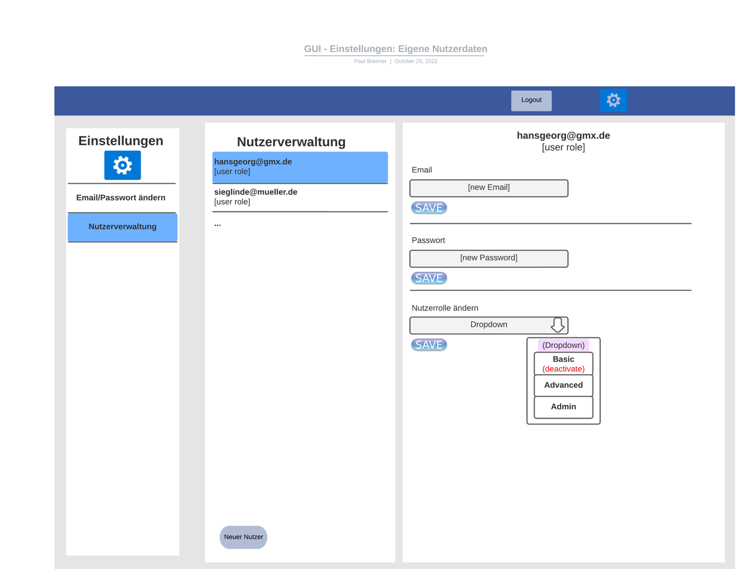

Figure 1 Settings Admin - v0.1

The web application shall have centralized management of identities and access permissions, with role-based access rights. The web application shall have functions for authentication and authorization of users and a self-service for users such as email and password change.

### /AASM-F20/ AAS content data management

The user (more precisely the user with the role of Admin) has the possibility to upload and delete AAS content. The content to be uploaded is in a file format.

### /AASM-F30/ Search functionalities

The user should be able to effectively find desired AAS content using search functions. The user should be able to effectively find the desired content of the AAS using search functions.

### /AASM-F40/ Rest-API Support <tbd with team if fullfilled>

The software shall support the Rest-API standard for communication between the client and database system.

### /AASM-F50/ Error Display

The software should check whether an error has occurred. If an error occurs, the user should receive an easily readable and understandable error message.

## Product Data

The following lists the data structures of the web application.

### /AASM-D10/ MongoDB

The web application should enable persistent data storage with MongoDB as the database management system used.

MongoDB is hosted on a Synology NAS using Ubuntu XX and MongoDB Version XX

## Other Product Characteristics

### /AASM-NF10/ Usability

Usability is to be ensured by a simple layout and by a human-centered interface. It should be clear and easy to use so that the user can achieve the objectives efficiently and satisfactorily.

### /AASM-NF20/ Reliability

Reliability is to be ensured by a responsive GUI with high error tolerance and a database with accurate and consistent data.

### System Environment

AAS Management is a web application and therefore only requires an Internet connection and an installed web browser on the computer work.

## Targetgroup

<Ihr Text>

# Release / Approval

Approval is made by the customer and the suppliers

|  |  |
| --- | --- |
| Date: |  |
| Signature Customer: |  |
| Signature Suppliers: |  |

# References

1. Blablabla